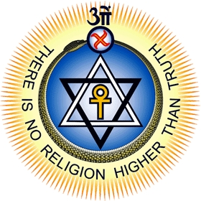
Philippine Theosophical Institute
1 Iba Street, Quezon City, Philippines
philtheos@gmail.com, (63-2)741-5740; 740-3751
Webpage: www.theosophy.ph
Correspondence Course on Theosophy
Course Guideline

Welcome to the Correspondence Course in Theosophy!

In this letter, you will find an outline of the procedure in taking the course.

- By this time, you would have submitted the Registration Form for the Course. You can of course study the course without having to register, but you will not be able to avail of the personal tutor (Course Correspondent) who will be answering your questions or discussing with you about issues that are of concern to you.
- The correspondence course is based on a textbook entitled: The Ageless Wisdom: Readings in Theosophy.
- The different lessons are available for download which you can read at your leisure. At the end of each lesson are questions that will help you check your comprehension of key ideas in the lesson. Write your answers to these questions in a Word file and attach it to an email addressed to your Course Correspondent.
- When you send an email to your Course Correspondent, it is suggested that you send a copy of your mail to corrcourse@gmail.com, so that just in case your Correspondent is on travel and unable to respond to you for an extended time, another resource person can temporarily act as your Correspondent.
- Download the last document entitled “For Further Reading” so that you will have a list of books that you may wish to read while you are studying this course.
- Use also the “Glossary of Terms” to know the meaning of unfamiliar terms
- Many of the books are available on line, either in the website of the Philippine Theosophical Society, or in another website. So we are also including a list of links to these books wherever they are available on online.
- At any time, feel free to ask questions to your Course Correspondent regarding any facet of your studies, including related fields.
- In receiving replies or in reading theosophical books, you are reminded that the Theosophical Society has no dogma or doctrine that binds its members. The principle of Freedom of Thought is basic to it. Hence no book or tutor should be taken as an authority that represents the views of the Theosophical Society.
- Should you at any time feel that you are inclined to be a member of the Theosophical Society (if you are not yet a member), then just request for an application form either from your Course Correspondent or by emailing philtheos@gmail.com. You will be sent an application form by postal mail.

